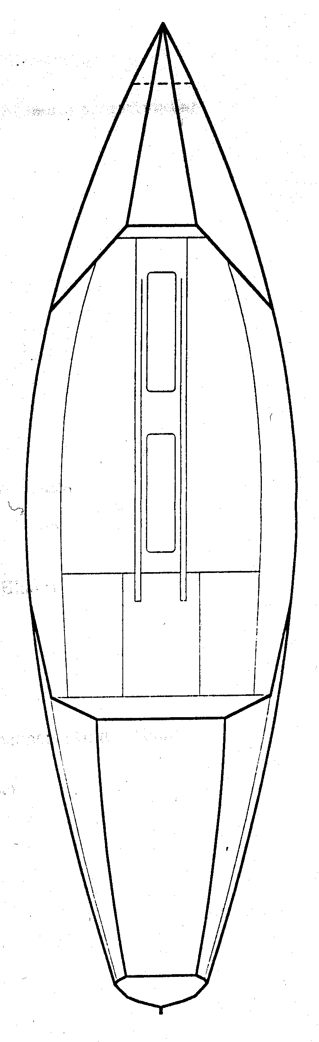
Electrical Box
Collision Avoidance Radar Detector
Running Light
12 DC Cigarette Plug Recepticles
Desalinator
Satellite Telephone Antenna
Standard C Antenna
Figure 1 Electrical Equipment and Outlets
Backup Solar Panel
Siemens Model SM-6
Main Solar Panels
Siemens Model SM-55
Solar Powered Vents
Nicro Day and Night 2000 Vents
Radar Reflector
Figure 2 Solar Panels and Solar Powered Vents

Electrical Box Viewed From Above

S
A
T
E
L
L
I
T
E

T
E
L
E
P
H
O
N
E
4
5
6
7
8
Standard C
Battery #2
Electrical
Panel #1
Electrical
Panel #2
Electric
Meter
(11)
344
Batt
Swt
(12)
9
10
Battery #1

2

N
E
G

B
U
S

1

- Antenna wire for Standard C, run through bulkhead with a “CableClam” Waterproof Through-Deck Fitting.
- Antenna wire for Satelite Telephone (Mini-M) run through bulkhead with a “CableClam” Waterproof Through-Deck Fitting.
- Electrical Wire to Deck 12-Volt Receptical run through bulkhead with a “CableGrip Wire Seal.”
- Electrical Wire to Deck 12-Volt Receptical run through bulkhead with a “CableGrip Wire Seal.”
- Electrical Wire to Running Light and VHF Charger run through bulkhead with a “CableGrip Wire Seal.”
- Electrical Wire to Desalinator run through bulkhead with a “CableGrip Wire Seal.”
- Electrical Wire to Collision Avoidance Radar Dectector run through bulkhead with a “CableGrip Wire Seal.”
- Electrical Wires Running From Solar Panels run through bulkhead with a “CableGrip Wire Seal.”
- 12 Volt “Cigarette Plug” Receptical (Used for DC Fan and Compass Light)
- 12 Volt “Cigarette Plug” Receptical (Used to Charge, Phone, Lap-top Computer and Video Camera)
- Link 10 Single Battery Bank Battery Monitor (E-Meter)
- Battery Switch (Battery #1, Battery #2, All, or Off)

Electrical Panel #1 Blue Sea Systems Three Switch DC Electrical Distribution Panel

Electrical Panel #2 Blue Sea Systems Six Switch DC Electrical Distribution Panel
Battery #1 – 32 Amp Hour 12 Volt Marine Gel Cell (24 Pounds)
Battery #2 – 32 Amp Hour 12 Volt Marine Gel Cell (24 Pounds)

1
2
3
1
2
3
4
5
6
Main Electrical Panel Mounted on Stern Wall of the Cabin Foot Well

(Left to Right)

Two 12 Volt Recepticals

Link 10 Battery Monitor

Electrical Panel #1

- Deck 12 Volt Plug
- Deck 12 Volt Plug
- VHF and Running Lights

Electrical Panel #2

- Cabin 12 Volt Plug
- Cabin 12 Volt Plug
- Collision Avoidance Radar Detector
- Standard C
- Mini-M Satelite Telephone
- Desalinator

Cream – Duplex Wire Sheathing
Black – Negative Wire
Red – Positive Wire
Blue – Waterproof Adhesive Lined Heat Shrink Tubing
Gold – Nylon Insulated Disconnect connected to the 12 Volt Electrical Panel
Circle – Waterproof Ring Terminal screwed to the Negative BusBar

12 Guage Marine Grade Sheathed Duplex Safety Wire
Negative wiring run to negative busbar with waterproof ring terminals and covered with adheasive lined heat shrink tubing.
Positive wiring run to electrical switch panels with fully insulated nylon disconnects and covered with adheasive lined heat shrink tubing.

Wire Seal #17 takes DC Receptacle wire through the compartment bulkhead.
Wire Seal #18 takes the second DC Receptacle wire through.
Wire Seal #19 takes the Desalinator wire through.
Wire Seal #20 takes running light wire through.
Wire Seal #21 takes CARD wire through.
Wire Seal #22 takes Solar Panel wire through.
CableClam #9 Standard C Antenna
CableClam #10 Mini-M Antenna
Wire Seal #8 takes Solar Panel wire through floor
Wire Seal #9 takes Solar Panel wire through floor
Wire Seal #10 takes CARD wire through floor
Wire Seal #11 takes Running Light through floor
Wire Seal #12 takes DC Receptacle wire through the compartment bulkhead.
Wire Seal #13 takes the second DC Receptacle wire through compartment bulkhead.
Wire Seal #14 takes the Desalinator wire through.
Wire Seal #15 takes running light wire through.
Wire Seal #16 takes Solar Panel wire through.
CableClam #7 Standard C Antenna
CableClam #8 Mini-M Antenna
Wire Seal #1 takes DC Receptacle wire through the Cabin Bulkhead.
Wire Seal #2 takes the second DC Receptacle wire through.
Wire Seal #3 takes the Desalinator wire through.
CableClam #5 Standard C Antenna
CableClam #6 Mini-M Antenna
Two 12 Volt DC Receptacles Mounted Through Seat Bulkhead
CableClam #3 takes Standard-C antenna through bulkhead.
CableClam #4 takes Mini-M antenna through bulkhead.
CableClam #2 through roof for Mini-M Antenna

CableClam #1 through roof for Standard-C Antenna
Wire Seal #4 takes Solar Panel wire through roof.
Wire Seal #5 takes Solar Panel wire through roof.
Wire Seal #6 takes CARD wire through roof.
Wire Seal #7 takes Running Light wire through roof.
Through-Hull Wiring and Electrical Fittings

